Michael Miller

2/4/20

Assignment 2

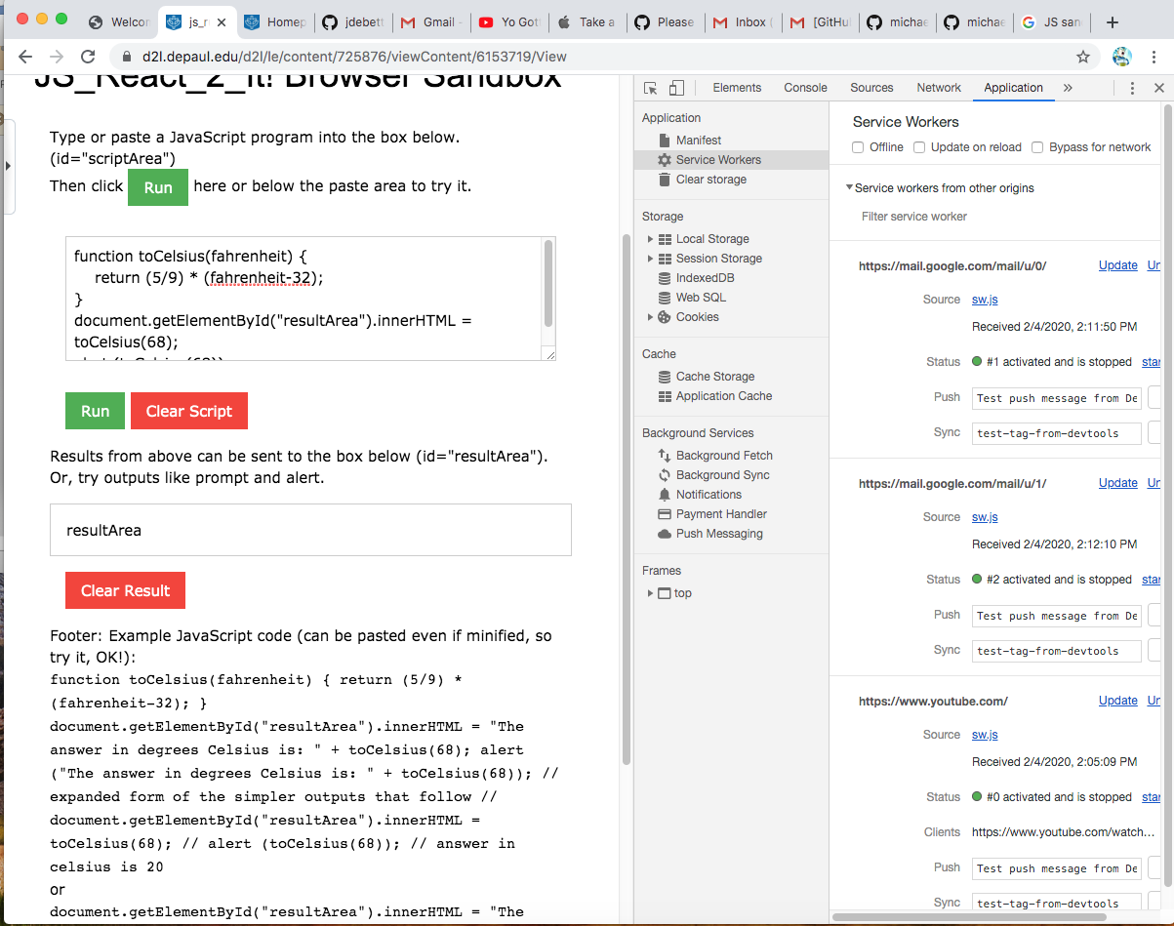

<https://github.com/michaelmiller75/IT338>